You can create a Dashboard in Excel 2007 using Pivot Tables, Pivot Charts, and Form Controls. Below is a simple Sales Dashboard example.

Step 1: Prepare Data
Month | Product | Region | Sales
Jan | Laptop | North | 25000
Jan | Mobile | South | 18000
Feb | Laptop | East | 30000
Feb | Tablet | West | 15000
Mar | Mobile | North | 22000
Mar | Laptop | South | 35000

Step 2: Create Pivot Table
- Select the data.
- Go to Insert → PivotTable.
- Place PivotTable in a new worksheet.
- Arrange fields:
  - Rows: Month
  - Values: Sum of Sales

Step 3: Create Charts
Go to Insert → Column Chart and create:
- Monthly Sales Chart
- Product-wise Sales Chart
- Region-wise Sales Chart

Step 4: Add KPI Boxes
Use merged cells and formatting to display:
KPI | Formula
Total Sales | =SUM(D2:D7)
Average Sales | =AVERAGE(D2:D7)
Maximum Sales | =MAX(D2:D7)
Minimum Sales | =MIN(D2:D7)

Step 5: Dashboard Layout
--------------------------------------------------
| SALES DASHBOARD |
--------------------------------------------------
| Total Sales | Average Sales | Max | Min Sales |
--------------------------------------------------
| Monthly Sales Chart |
--------------------------------------------------
| Product-wise Sales Chart |
--------------------------------------------------
| Region-wise Sales Chart |
--------------------------------------------------

Excel 2007 Features Used
- Pivot Tables
- Pivot Charts
- Conditional Formatting
- Data Bars
- Shapes and Text Boxes
- Form Controls (Drop-down Lists)

Example Dashboard
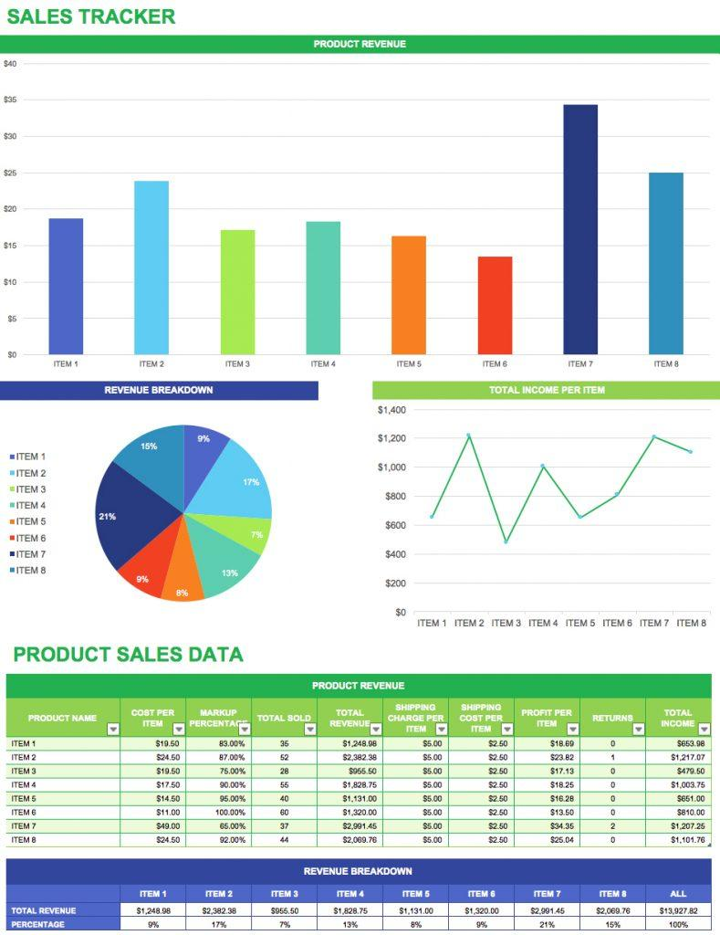
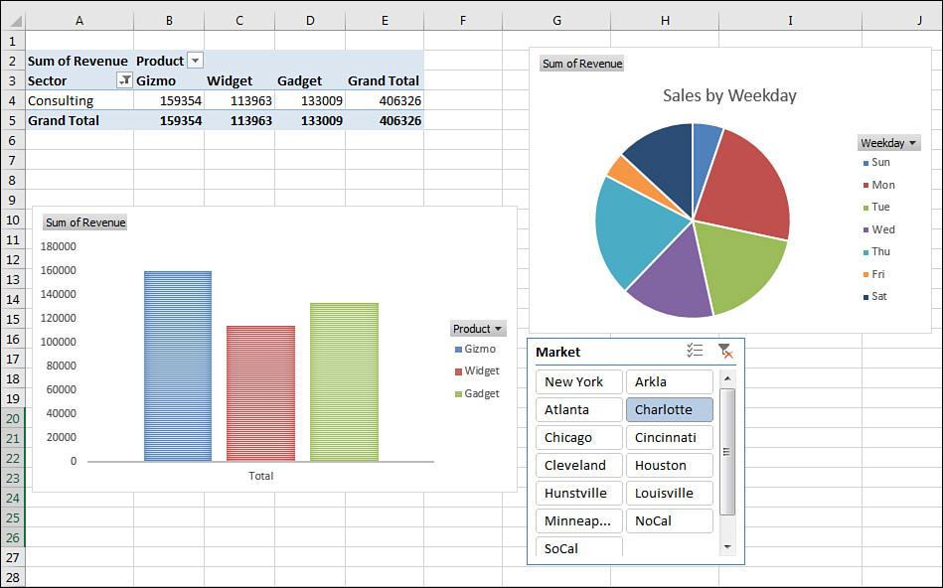

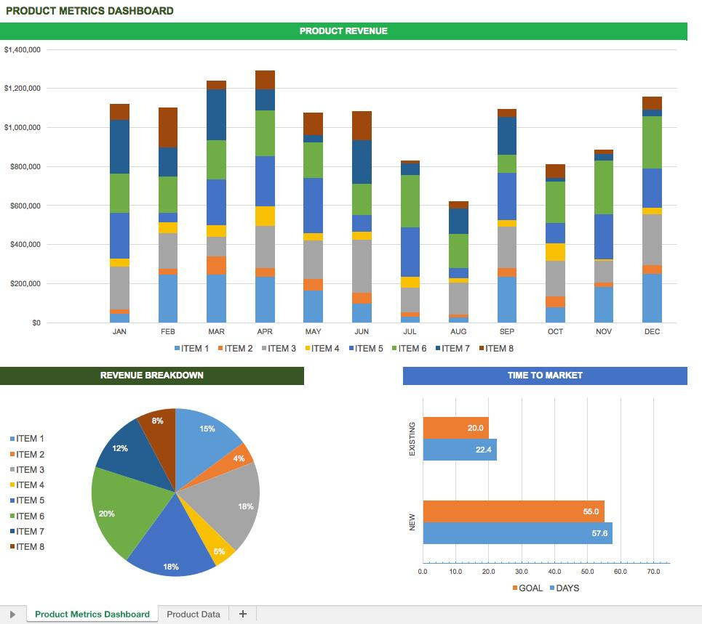
4
If you want, I can create a fully working Excel 2007 dashboard (.xlsx file) with sample data and charts that you can download and use directly.

